1. A constantly accelerating particle travels for 3 s. If its initial velocity is 10 m/s and it travels 75 m, what is its acceleration?

(A) 5 m/s2

(B) 10 m/s2

(C) 16.67 m/s2

(D) 25 m/s2

(E) 30 m/s2

2. A projectile launched straight up at 10 m/s will be in the air for:

(A) 1 s

(B) 1.4 s

(C) 2 s

(D) 5 s

(E) 7 s

3. An object moving at 10 m/s makes a circle with a 2 m radius. The object accelerates at:

(A) 10 m/s2

(B) 20 m/s2

(C) 50 m/s2

(D) 100 m/s2

(E) 150 m/s2

4. A 5 kg object is dropped from a plane. At 3 s, it reaches terminal velocity (Its maximum velocity due to air resistance). What is the object’s terminal velocity?

(A) Much less than 30 m/s

(B) Approximately 30 m/s

(C) Much more than 30 m/s

(D) Exactly 45 m/s

(E) Exactly 47.5 m/s

5. A 3043 N rocket lifting off the Earth's surface accelerated upward at 38.2 m/s2. What force did the rocket's motor supply?

(A) 98000 N

(B) 10000 N

(C) 15100 N

(D) 12000 N

(E) 14904 N

6. A car traveling along a level curve with a radius of curvature of 41.6 m hits a patch of ice where the coefficient of friction is 0.435. Above what speed will the car skid?

(A) 12 m/s

(B) 11.55 m/s

(C) 12.1 m/s

(D) 12.95 m/s

(E) 13.32 m/s

7. The moon has an orbital period of 27.3 days and a mean distance of 3.80×105 km from the center of the Earth. Find the distance an artificial satellite is from the center of Earth if its period is 82.5 minutes.

(A) 1000 km

(B) 4500 km

(C) 6000 km

(D) 7333 km

(E) 6227 km

8. A gun shoots a bullet at 290 m/s at an angle of 61.7º above the horizontal. The bullet embeds into a tree at the same height as it left the muzzle. Neglecting air resistance, determine the bullet's time of flight in seconds.

(A) 67.7 s

(B) 76.5 s

(C) 22.8 s

(D) 52.1 s

(E) 44.3 s

9. A forklift is used to raise a 235 kg load from the floor to a height of 3.96 m. If the forklift expends 1508 W of power, how many seconds does it take to lift the load?

(A) 4.0 s

(B) 4.90 s

(C) 4.50 s

(D) 2.00 s

(E) 6.05 s

10. The block is lowered by a rope as shown. The tension T in the rope is 35 N. If the block is lowered 10 m, how much work is done on the block by the rope?

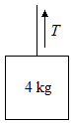

(A) -50 J

(B) -175 J

(C) -350 J

(D) -400 J

(E) -500 J

11. A pendulum with a mass of 0.255 kg and a length of 1.136 m is displaced through an angle of 36.7º then released. Eventually the maximum angle of swing is only 10º. How much energy has been lost to friction?

(A) 0.3 J

(B) 0.6 J

(C) 0.1 J

(D) 0.14 J

(E) 0.53 J

12. A body loses 4655 J of potential energy in falling through 95 m. If the gravitational acceleration is 9.8 m/s2, then the body has a mass of

(A) 4 kg

(B) 3 kg

(C) 7 kg

(D) 8 kg

(E) 5 kg

13. A large object moving at 10 m/s to the right collides with a lighter object that is initially stationary. Which of the following is a possible velocity of the lighter object after the collision?

(A) 1 m/s to the right

(B) 5 m/s to the right

(C) 18 m/s to the right

(D) 25 m/s to the right

(E) 28 m/s to the right

14. The crane below uses a steel cable to lift one end of a 1000 kg iron sheet as shown. The crane has a mass on 4000 kg and sits 1 m from the left end of the sheet. In the sheet is 10 m long and of uniform density, what is the minimum tension in the cable?

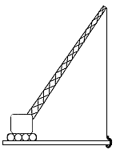

(A) 5200 N

(B) 5500 N

(C) 6000 N

(D) As shown in the diagram, the crane could not move the iron sheet.

(E) 8000 N

15. Scientists are able to date certain objects based upon the ratio of 14*C* to 12*C* within those objects. 14*C* decays via $β$-particle production to form:

(A) 13*b*

(B) 14*b*

(C) 13*n*

(D) 14*n*

(E) 12*n*

16. A block of a certain substance measures 4 cm3 cm10 cm and weighs 60 grams. A second block of the same substance measures 40 cm30 cm100 cm. What is the specific gravity of the second block?

(A) 0.5

(B) 2

(C) 5

(D) 500

(E) 1000

17. An open container of fluid begins draining a spigot at time t = 0. Assume ideal fluid flow. If the container is filled with water, and h is 20 m, the pressure at c is:

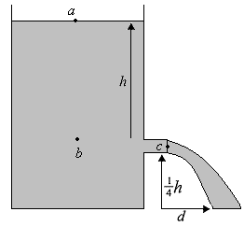

(A) 1 atm

(B) 2 atm

(C) 3 atm

(D) 4 atm

(E) 5 atm

18. A 2 kg object initially at rest is struck head-on by a 4 kg object moving at a velocity of 2 m/s. After the collision, the two objects stick together. Let Kb be the kinetic energy of the system before the collision, and let Кa be the kinetic energy of the system after the collision. Calculate the ratio Кa/Kb.

(A) 1

(B) 0.33

(C) 0.25

(D) 0.5

(E) 0.67

19. A 2 kg rock is thrown vertically upward at a speed of 3.2 m/s from the surface of the moon. If it returns to its starting point in 4 seconds, what is the acceleration due to gravity on the moon?

(A) 10 m/s2

(B) 7.5 m/s2

(C) 75 m/s2

(D) 1.6 m/s2

(E) 20 m/s2

20. A glass tube closed at one end is placed in front of a loud speaker fed by an audio oscillator of variable frequency. Air in the tube resonates when the speaker emits sound at a frequency of 425 Hz and 1275 Hz. What is the length of the tube? (Note: Assume the speed of sound is 340 m/s.)

(A) 10 cm

(B) 20 cm

(C) 30 cm

(D) 40 cm

(E) 50 cm

21. Calculate the tension in a cable used to pull a 1000 kg object straight upward at an acceleration of 0.7 m/s2. (Use g = 9.8 m/s2.)

(A) 49000 N

(B) 5000 N

(C) 2500 N

(D) 14000 N

(E) 10,500 N

22. What is the voltage across the capacitor and the charge on the capacitor?

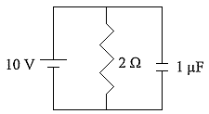

(A) 5 V, 510-6 C

(B) 5 V, 10-5 C

(C) 10 V, 510-6 C

(D) 10 V, 10-5 C

(E) 10 V, 10-6 C

23. A generator produces electricity in the form of alternating current with a frequency of 50 cycles per second. If the rms voltage is 100 V, approximately what is the maximum potential difference created by the generator?

(A) 50 V

(B) 71 V

(C) 141 V

(D) 200 V

(E) 100 V

24. A ball launched horizontally from a platform lands 3 m away from the base of the platform after 1 sec. From what height was it launched?

(A) 1 m

(B) 3 m

(C) 5 m

(D) 7 m

(E) 9 m

25. The 4 kg mass is pulled to the right by the unknown mass *M*, over a tabletop having a coefficient of friction of 0.25 with the 4 kg mass. The pulley is frictionless. If the 4 kg mass accelerates at a rate of 2 m/s2, the value of the unknown mass *M* is most nearly

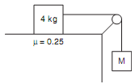

(A) 2 kg

(B) 4 kg

(C) 6 kg

(D) 8 kg

(E) 10 kg

26. The equivalent resistance of the circuit is

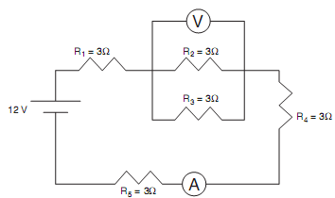

(A) 5 Ω

(B) 7 Ω

(C) 9 Ω

(D) 11 Ω

(E) 12 Ω

27. Two capacitors, 0.8 µF and 1.0 µF are connected in parallel and charged to a 120 V potential difference. The total charge acquired by the capacitors is most nearly

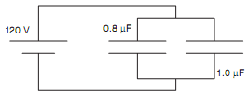

(A) 0.2 µC

(B) 2 µC

(C) 22 µC

(D) 216 µC

(E) 2160 µC

28. A 5 µF capacitor *C*1 is charged to an initial potential difference of 12 V and connected to an initially uncharged 13 µF capacitor *C*2 and an open switch. When the switch is closed, the final potential difference *V*final across both *C*1 and *C*2 is most nearly

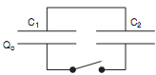

(A) 1 V

(B) 3 V

(C) 5 V

(D) 7 V

(E) 9 V

29. The work necessary to move a point charge of 2×10–3 C from the origin to another point 1.5 m away is 3 J. The potential difference between the two points is

(A) 4.5×10–4 V

(B) 1.5×10–3 V

(C) 3×10–2 V

(D) 103 V

(E) 1.5×103 V

30. Two concentric squares of sides *s* and 2*s*, respectively, are made of the same type and thickness of wire. They lie in the same plane, as shown. If the resistance of the larger square is *R*, the resistance of the smaller square is

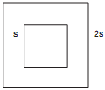

(A) 0.25*R*

(B) 0.5*R*

(C) *R*

(D) 2*R*

(E) 4*R*